Outdoor Education Plan
Lesson Focus – Sound
Year Group - Years 3, 4, & 5 |  | Term - Two | Date – Week 5/11/18
 | Outline | Curriculum Links/  Learning Objectives | Health and Safety considerations | Equipment
Session Procedures | Before - Check for rubbish, glass, hazards. Check weather forecast  During – Remind children about looking after their eyes.  After – clear everything away and return any natural objects to their original place  Clean hands. | Sc4/4.1a identify how sounds are made, associating some of them with something vibrating  Sc4/4.1b recognise that vibrations from sounds travel through a medium to the ear  Sc4/4.1c find patterns between the pitch of a sound and features of the object that produced it  Sc4/4.1d find patterns between the volume of a sound and the strength of the vibrations that produced it.  Sc4/4.1e recognise that sounds get fainter as the distance from the sound source increases | Wash hands after touching outside objects  Remind the children about how sharp some sticks can be and to be careful of brambles and stinging nettles. | Instruments,  Material  Cups  String  Scissors
Introduction and Activity Opportunities | Start of Lesson –Begin the lesson in class discussing the brain and how we think our ears work http://www.childrensuniversity.manchester.ac.uk/learning-activities/science/the-brain-and-senses/introduction/  How does sound travel? https://www.bbc.com/bitesize/articles/z3wf34j  Outside today we are going to be carrying out some tests to do with sound.  (This is a lessons which will be building on the skills that we used during the tests that we carried out on the muddy water. You will have to create a clear fair test and work as a TEAM).  Using the equipment provided you will need to answer these questions:  Part One  - How are sounds made? (test the instruments and see if you can feel vibrations)  - How can you change the volume of a sound? (larger instrument, hitting harder, distance from sound, insulation from sound – record the pattern made by your findings)  - How can you change the pitch of a sound (what is pitch)? (map the pattern of your findings – larger = lower/smaller = higher)  Part Two (or in event of bad weather – in class)  - Can sounds travel along solid objects or just through the air? (make cup telephones).  - Which materials make the best sound insulators? (Use different materials to cover your ears and test whether you can hear the same sound or not – can you make it a fair test) |  |  | Vocabulary
Sound
Volume
Pitch
Pinna
Ear Canal
Hammer
Stirrup
Anvil
Cochlea
Auditory Nerve

Plenary | What have you learnt about sound? Was anything new/unexpected?  What did you have to do to make it a fair test?  Did you manage to work as a team successfully? | Evaluation

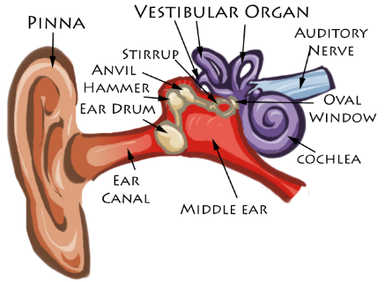
Sound Evaluation Sheet – while you are investigating see if you can answer these questions.
How are sounds made? _____________________________________________________________
Could you get the sound to travel along anything solid?__________________________________
How did you change the pitch of the sound? __________________________________________________
Change to Instrument/Pitch | High | Medium | Low

Did you change the volume of the sound? ___________________________________________________________________
How did you change the volume? ___________________________________________________________________________
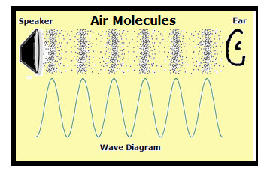
Which materials did you try for the insulator?_________________________________________________________________
Which material made the best ear muff/insulator?________________________________
Which sound test that you carried out was the most interesting? _________________________________________________________________________
What would you test next, knowing what you know now? _________________________________________________________________________
Make a String Telephone
What you'll need:
- 2 paper cups
- A sharp pencil or sewing needle to help poke holes
- String (kite string and fishing lines work well)
Instructions:
- Cut a long piece of string, you can experiment with different lengths but perhaps 20 metres (66 feet) is a good place to start.
- Poke a small hole in the bottom of each cup.
- Thread the string through each cup and tie knots at each end to stop it pulling through the cup (alternatively you can use a paper clip, washer or similar small object to hold the string in place).
- Move into position with you and a friend holding the cups at a distance that makes the string tight (making sure the string isn't touching anything else).
- One person talks into the cup while the other puts the cup to their ear and listens, can you hear each other?
What's happening?
Speaking into the cup creates sound waves which are converted into vibrations at the bottom of the cup. The vibrations travel along the string and are converted back into sound waves at the other end so your friend can hear what you said. Sound travels through the air but it travels even better through solids such as your cup and string, allowing you to hear sounds that might be too far away when traveling through the air.
More about phones:
Landline telephones feature microphones that convert sound waves into electric currents that are then sent through wires and converted back into sound waves by an earphone inside the telephone at the other end. Modern mobile phones use radio waves (part of the electromagnetic spectrum that includes microwaves, infrared, visible light, X-rays and others) to communicate with base stations located throughout telephone networks.
Phones have come a long way since Alexander Graham Bell was awarded the first electric telephone patent by the United States Patent and Trademark Office back in 1876. Today’s cell phones are a marvel of modern technology, featuring not only the ability to make phone calls but to also surf the web, play music, view documents and much more.
Step back in time and use some old fashioned technology to make a string phone while learning about sound waves with this fun science project for kids.
All you need is some string, a sharpened pencil and a few paper cups to get started.

