|  |  |  |  |  |
| --- | --- | --- | --- | --- |
| **Outdoor Education Plan** | | | | |
| **Lesson Focus – Understand that we use our senses to notice different aspects of the world and introduce how our body works** | | | | |
| **Year Group - Key Stage One and Two** | | **Term - Six** | **Date – Week 1 - 3** | |
|  | **Outline** | **Curriculum Links/**  **Learning Objectives** | **Health and Safety considerations** | **Equipment** |
| **Session Procedures** | **Before** - Check for rubbish, glass, hazards.  Check weather forecast  **During –** Watch that children do not go outside of the boundary and that they stay off of the muddy sloped area.  **After** – clear everything away and return any natural objects to their original place  **Wash hands when back in school** | **I am beginning to understand how my eyes, ears, finger tips or tongue work**  **I know what my senses are.**  **I can use my senses to describe the world.** | Wash hands after touching outside objects  Remind the children about how sharp some sticks can be and to be careful of brambles and stinging nettles.  In the park remind children about not touching dogs or cats.  Stay within the set out boundaries.  Dog mess warning – let teacher know. | Palettes  Sticky back plastic  Cups  Pea shoots  Blind folds  Hi - Viz |
| **Introduction and Activity Opportunities** | **Main Activity – Earth Walk at the park.**   * **Crash land the space ship –** explain that the children have crash landed on a distant planet. The hypersleep is still active and so they can not move or open their eyes. They can only hear – for 10 minutes **locate the sounds** all around. Explain that the base have sent instructions for further research of the planet. * **Feely trays -** Find 6 objects with different feels (soft, hard, smooth…) and place them on the palette. * **Smelly potion –** collect items in the pot with smells and mix in some water to make a good smell. * **Colour Palette –** Collect as many colours as possible and stick them on the sticky back plastic – how many shades of green can you find? * **Taste the pea sprouts -** taste the pea sprouts from the garden * If you were newly landed on earth what would you notice about it? * Stick them onto the sticky back plastic * Make a frame out of cardboard/paper * Put the sticky back plastic in the frame. | **Vocabulary** |
| Senses  Smell  Taste  Touch  Feel  Hearing  Anatomy terms |
| **Plenary** | **Plenary –**  [**http://www.childrensuniversity.manchester.ac.uk/learning-activities/science/the-brain-and-senses/introduction/**](http://www.childrensuniversity.manchester.ac.uk/learning-activities/science/the-brain-and-senses/introduction/)  **Look together at the Manchester Children’s University website to find out how our senses could see, hear, taste, touch and smell the park** | **Evaluation** | | |

**Smelly cocktails**

Can you find the smelliest ingredients in the garden to make a pongee perfume?!

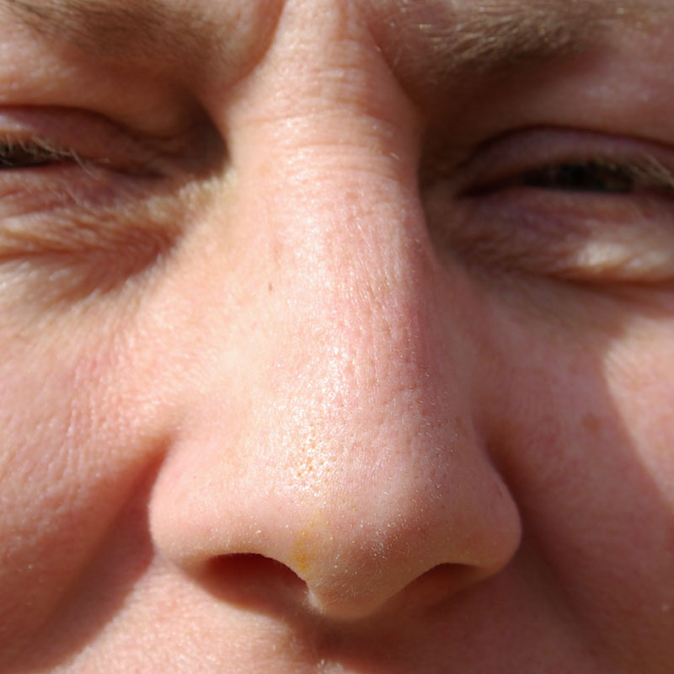

Did you smell the compost, soil or tree bark?

**Colour Palette**

How many colours can you find in the garden to put on your colour palette?

(stick small bits of leaf etc on the card)

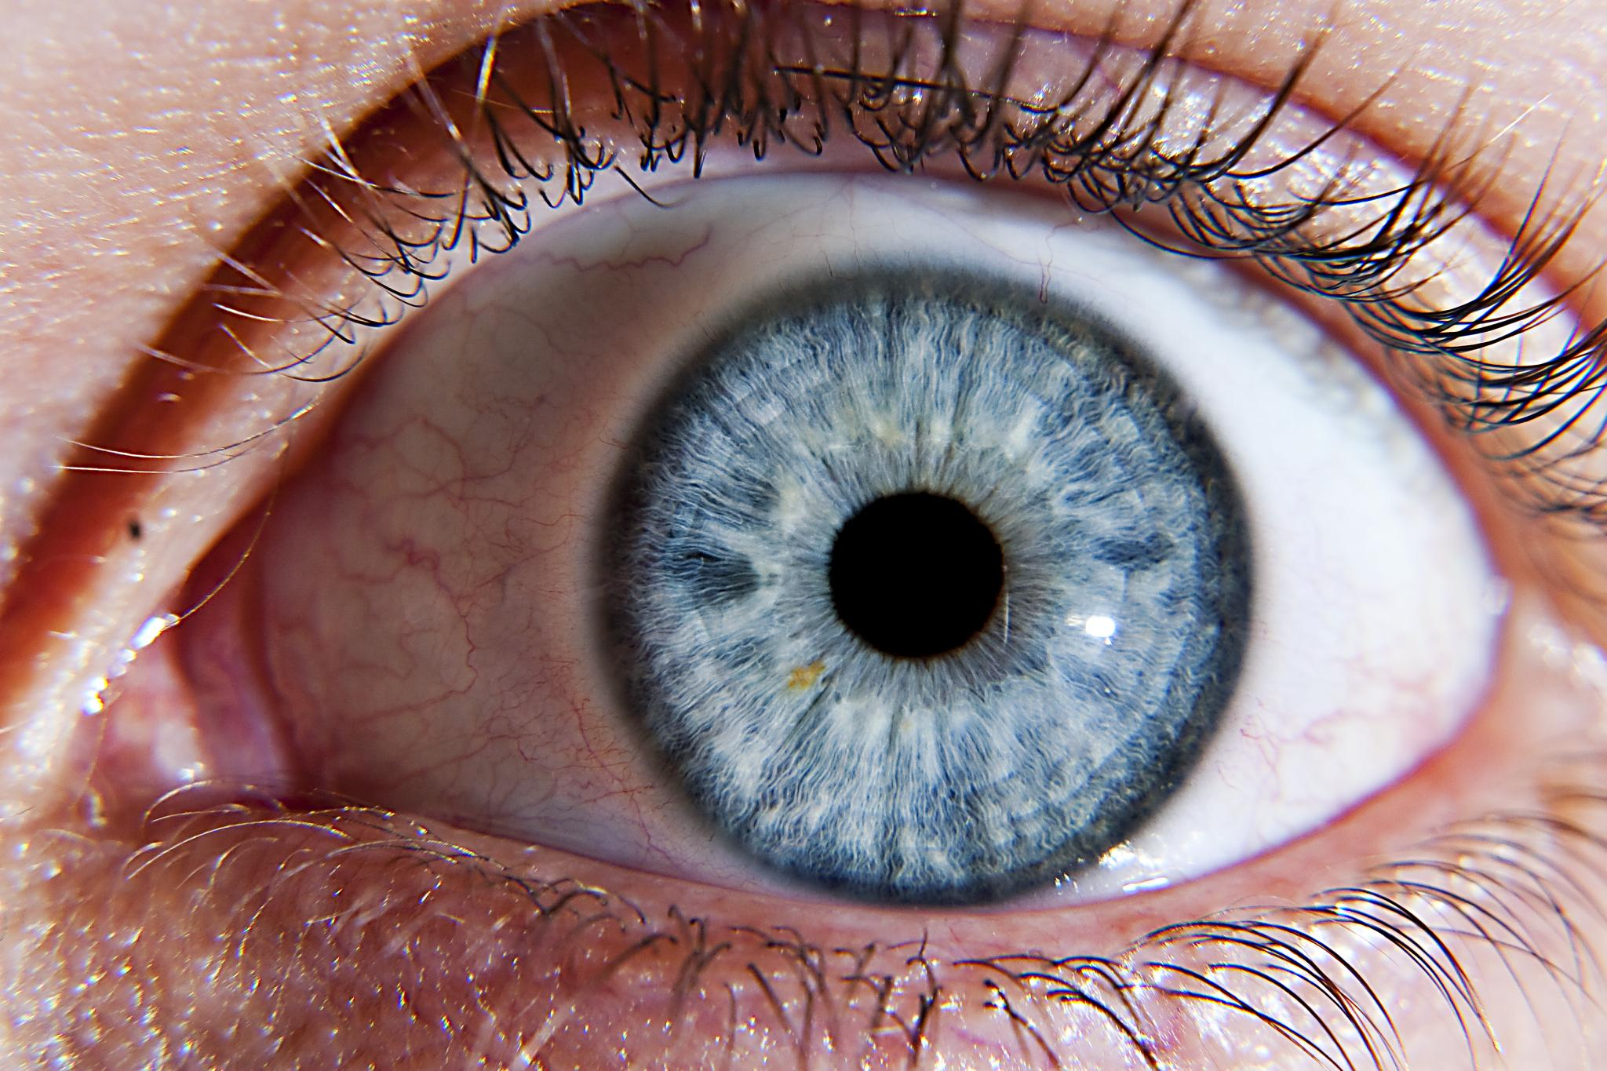

How many shades of green did you find?

**Taste Sensation**

Can you describe the taste of clover leaf?

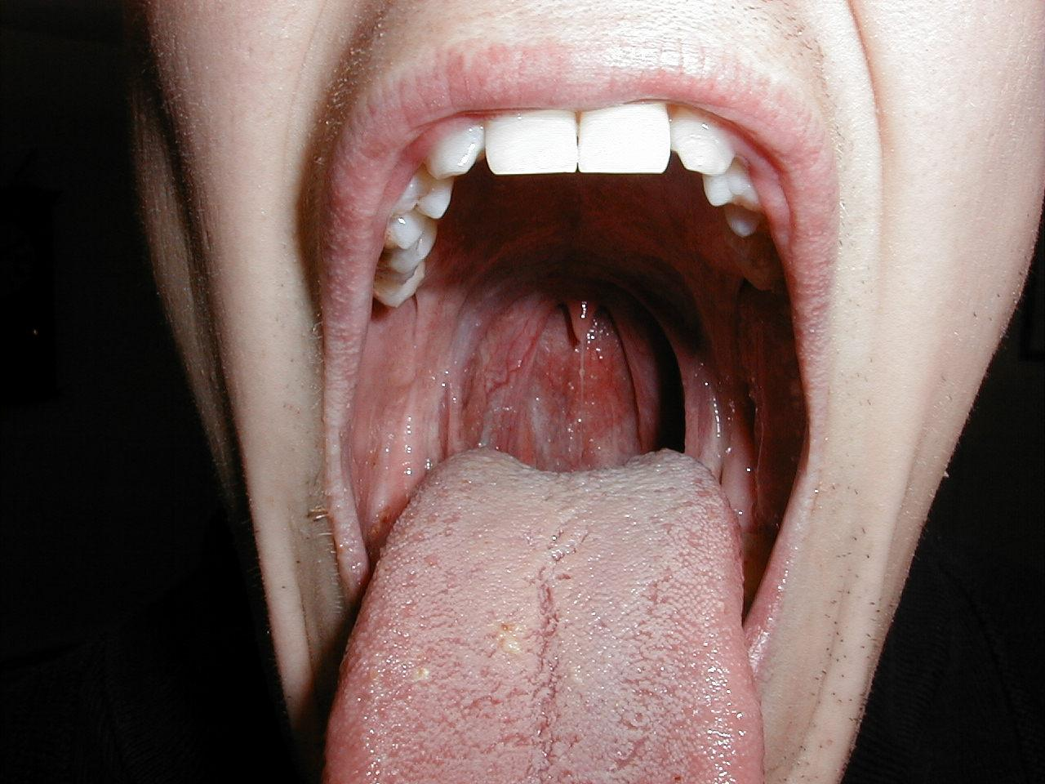

What do you think it would go well with?

**Sound Locator**

Sit absolutely still with your eyes closed. What can you hear around you?

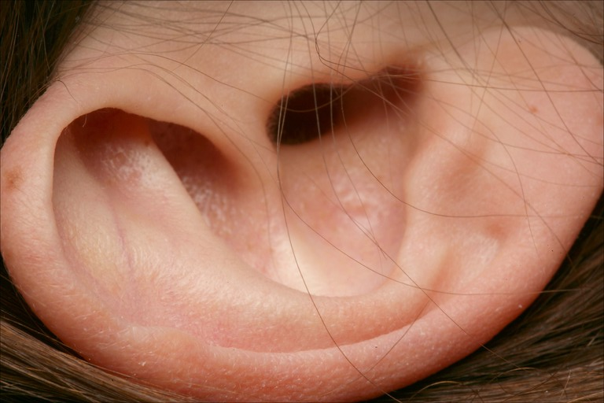

Can you hear any birds, bugs or vehicles?

**Feely Boxes**

Can you collect 6 objects with different textures in your egg box?

(make sure that everything goes back where you found it)

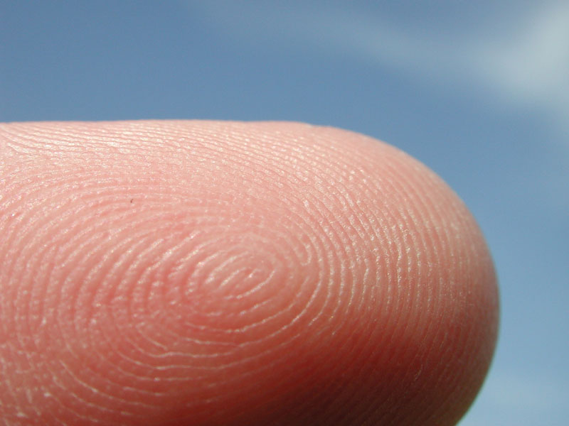

Did you find anything hard, soft, smooth, soft, prickly, tickly, sharp, crispy, fluffy, bumpy or squashy?

**Earth Walk**

**There are 5 tasks on the earth walk.**

**You will have to use**

**all your senses to**

**complete it.**

