Year Group - 1 and 2  Do the materials change in the fire?  Do the materials change when you squash, twist, bend and stretch them? |  | Date – Term Three
Curriculum Links | - Year 1  - describe the simple physical properties of a variety of everyday materials  - compare and group together a variety of everyday materials on the basis of their simple physical properties.  - Year 2  - identify and compare the suitability of a variety of everyday materials, including wood, metal, plastic, glass, brick, rock, paper and cardboard for particular uses  - find out how the shapes of solid objects made from some materials can be changed by squashing, bending, twisting and stretching.
Session Procedures | Before - Check for rubbish, glass, hazards. Check weather forecast. Make sure that the fire circle and area are safe for the cooking.  During – Keep vigilant regarding broken branches, slippery ground  Wear Hi-Viz jacket. Road safety to get to the park  After – clear everything away and return any natural objects to their original place  Wash hands | - Wash hands after touching outside objects  - Remind the children about how sharp some sticks can be and to be careful of brambles and stinging nettles.  - Gloves must be worn for both litter picking and gardening  - The school grounds are our classroom and must be treated with respect. | Equipment  Fire Equipment  Bread dough, willow sticks, wax, corn kernels  Clay, rock, sponge, wool, spoon, play dough, putty
Introduction and Activity Opportunities | Main activity  How do material change when they are put over/in the fire?  Remind the class about the fire safety precautions.  Make predications as to what will happen to each material when it is placed in the fire.  Whittle a hazel stick for the bread dough whilst the wax, willow sticks and corn kernels are placed in the fire.  Place the bread dough over the fire on the hazel stick.  How do materials change when bent, twisted, stretched and squashed?  Explain that the children are going to have to test each of the materials to see if they bend, twist, stretch or squash. |  | Vocabulary  Material  Reaction  Bend  Twist  Change  Heat
Plenary | All of the activities that we carried out today are science experiments – how is this information important in the everyday?

TRANSFIGURATION LESSON

Professor McGonagall has
given you some spells to cast.

You will need to try each of these actions on the materials you have in your tray.

Material | Bend | Twist | Stretch | Squash
Putty 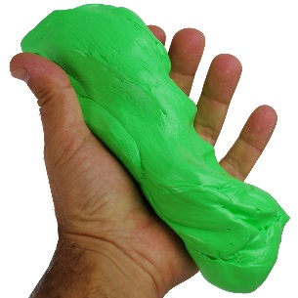
Balloon
Wood 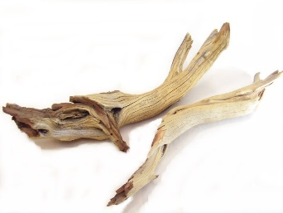
Material | Bend | Twist | Stretch | Squash
Paper
Rock 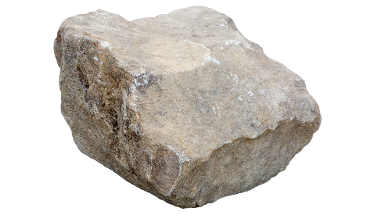
Sponge 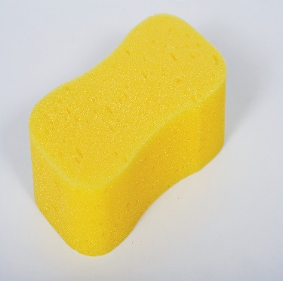
Wool 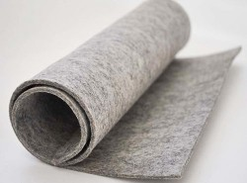

Metal Spoon
