Year Group - Reception  ‘Shark in the Park’ by Nick Sharratt |  | Date – Term Two
Curriculum Links | Communication and language development  ELG 01 Listening and attention: children listen attentively in a range of situations. They listen to stories, accurately anticipating key events and respond to what they hear with relevant comments, questions or actions. They give their attention to what others say and respond appropriately, while engaged in another activity.  ELG 02 Understanding: children follow instructions involving several ideas or actions. They answer ‘how’ and ‘why’ questions about their experiences and in response to stories or events.  ELG 03 Speaking: children express themselves effectively, showing awareness of listeners’ needs. They use past, present and future forms accurately when talking about events that have happened or are to happen in the future. They develop their own narratives and explanations by connecting ideas or events.  Physical development  ELG 04 Moving and handling: children show good control and co-ordination in large and small movements. They move confidently in a range of ways, safely negotiating space. They handle equipment and tools effectively, including pencils for writing.  ELG 05 Health and self-care: children know the importance for good health of physical exercise, and a healthy diet, and talk about ways to keep healthy and safe. They manage their own basic hygiene and personal needs successfully, including dressing and going to the toilet independently.  ELG 06 Self-confidence and self-awareness: children are confident about trying new activities, and say why they like some activities more than others. They are confident speaking in a familiar group, will talk about their ideas, and will choose the resources they need for their chosen activities. They say when they do or don’t need help.  ELG 07 Managing feelings and behaviour: children talk about how they and others show feelings, talk about their own and others’ behaviour, and its consequences, and know that some behaviour is unacceptable. They work as part of a group or class, and understand and follow the rules. They adjust their behaviour to different situations, and take changes of routine in their stride.  ELG 08 Making relationships: children play co-operatively, taking turns with others. They take account of one another’s ideas about how to organise their activity. They show sensitivity to others’ needs and feelings, and form positive relationships with adults and other children.  Mathematics  ELG 12 Shape, space and measures: children use everyday language to talk about size, weight, capacity, position, distance, time and money to compare quantities and objects and to solve problems. They recognise, create and describe patterns. They explore characteristics of everyday objects and shapes and use mathematical language to describe them.  Understanding the world  ELG 14 The world: children know about similarities and differences in relation to places, objects, materials and living things. They talk about the features of their own immediate environment and how environments might vary from one another. They make observations of animals and plants and explain why some things occur, and talk about changes.  Expressive Arts and Design  ELG 17 Being imaginative: children use what they have learnt about media and materials in original ways, thinking about uses and purposes. They represent their own ideas, thoughts and feelings through design and technology, art, music, dance, role-play and stories.
Session Procedures | Before - Check for rubbish, glass, hazards. Check weather forecast  During – Wear Hi-Viz jacket. Road safety to get to the park. Being careful not to run in areas of sticks  After – clear everything away and return any natural objects to their original place  Wash hands | - Wash hands after touching outside objects  - Remind the children about how sharp some sticks can be and to be careful of brambles and stinging nettles.  - Remind children to be careful not to let the sticks fly out of their hands and go in someone else’s eye.  - Gloves must be worn for both litter picking and gardening  - The school grounds are our classroom and must be treated with respect.  No sticking  No picking  No licking  Look after yourself, each other and the outdoors | Equipment  ‘Shark in the Park’  Water proofs  High-viz  String  Markers  Mirrors  scissors
Introduction and Activity Opportunities | Start of Lesson – Discuss crossing the road and how we cross it. Explain that we must wear high-viz to go to the park.  - Walk to the park keeping together.  - At the park sit on the bandstand or tarp under the trees and read the ‘Shark in the Park’ book.  - Using the tubes, look around the park to see what we can see.  - Go for a tree top mirrors walk – walk along looking in a mirror pointing up at the trees.  Stick Reindeer  - Children collect different size and shape sticks to make reindeer with. They need a thick stick for the body and two thin sticks for the antlers. Use pre-cut lengths of hazel for the best results.  - Tie the antlers onto the body with twine.  - Whittle a small area from the top of the stick for the face.  - Draw eyes and a red nose onto the thick stick for a face.  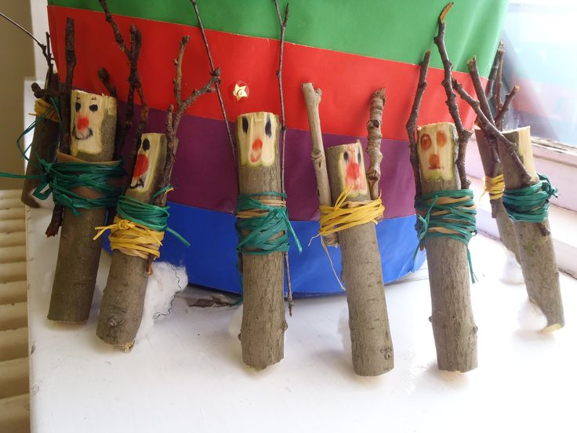 |  | Vocabulary  Park  See  Telescope  Shark  view  Reindeer  Sticks  Plants
Plenary | In the classroom  - Wash Hands  - Take turns telling everyone their favourite thing about the afternoon

