Outdoor Education Plan
Lesson Focus – Tree Character Design
Year Group - Years F - 6 |  | Term - | Date – Week
 | Outline | Curriculum Links/  Learning Objectives | Health and Safety considerations | Equipment
Session Procedures | Before - Check for rubbish, glass, hazards. Check weather forecast  During – If in public space keep an eye out for dog poo  After – clear everything away and return any natural objects to their original place  Clean hands. | I can design and sculpt a clay tree character | Wash hands after touching outside objects  Remind the children about how sharp some sticks can be and to be careful of brambles and stinging nettles.  Remind children to be careful not to let the sticks fly out of their hands and go in someone else’s eye.  Gloves must be worn for both litter picking and gardening  No Picking  No Licking  No Sticking  Look after each other | clay
Introduction and Activity Opportunities | Starter activity – If you were a tree imagine what sort of character you would be. Does it matter what sort of tree you are? Can you pull the sort of face that you imagine the tree would have?  Main Activity  - We are making clay tree character faces for the trees on the school grounds.  - Take care choosing your tree – how does it’s bark feel and look and does it have lots of branches? Does it have a character?  - Using the resources around you and the clay sculpt a character on the tree.  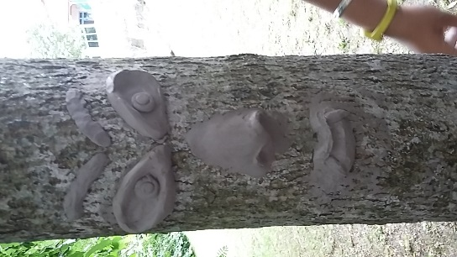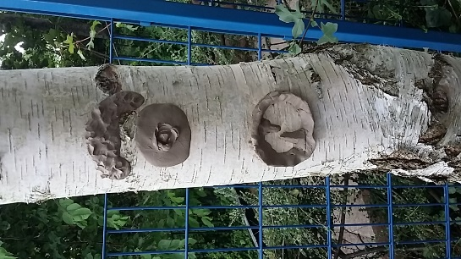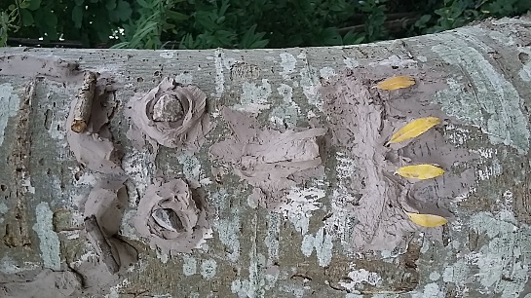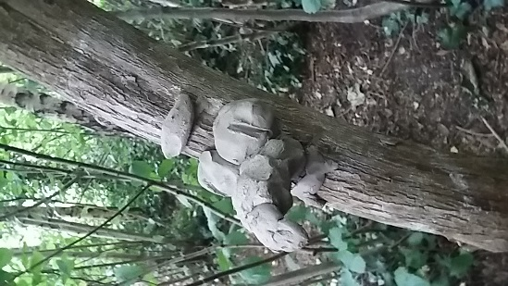 |  |  | Vocabulary
Design
Magic
Character
Happy
Sad
Scary
Ugly
Pretty
Beautiful…

Plenary | Using lots of adjectives how would you describe your character. | Evaluation

