Outdoor Education Plan
Lesson Focus – Wild Flower Identification and Flower Part Labelling
Year Group - Year 4, 5 & 6 |  | Term - Six | Date – Week 6.6.16
 | Outline | Curriculum Links/  Learning Objectives | Health and Safety considerations | Equipment
Session Procedures | Before - Check for rubbish, glass, hazards. Check weather forecast  During – Wear Hi-Viz jacket. Road safety to get to the park  After – clear everything away and return any natural objects to their original place  Clean hands. | I can explain why flowers are important.  I can identify some parts of the flowers reproductive parts.  I can identify 5 common British flowers | Wash hands after touching outside objects  Remind the children about how sharp some sticks can be and to be careful of brambles and stinging nettles.  Remind children to be careful not to let the sticks fly out of their hands and go in someone else’s eye.  Gloves must be worn for both litter picking and gardening | Flower ID sheet  Flowers part sheet  Cotton  Stones  Sticky plastic
Introduction and Activity Opportunities | Indoors – remind road safety and Park behaviour before leaving – put on HI Viz jackets.  Main Activity  - Recap – What are flowers for?  - Where might we find them (all plants)? Why are they all different? (adaptation)  - How can we ID them? Why might there be different flowers in different parts of the cemetery? (habitat)  - Visit the cemetery to discover which wild plants grow in Kingswood. – what plants might we expect to find?  https://files.hamilton-trust.org.uk/session/ks1_sc_y1_sb_plants_0.doc  - Back at school use the Flower parts sheet from ‘Primary Science KS2 book’ to identify all the parts of the flower.  - If there is time - using the flowers create flags with Hapa Zome technique – hammer the flowers onto material to get the natural dye and shape from them.  http://kindlingplayandtraining.co.uk/crafts-and-projects/hapa-zome-beating-up-leaves-with-hammers/  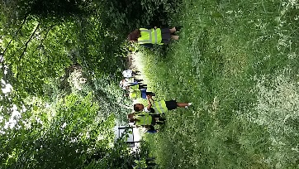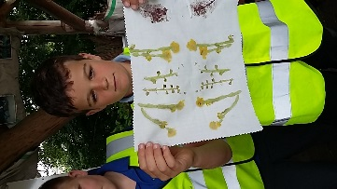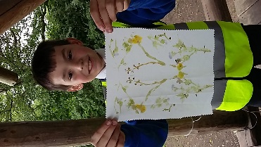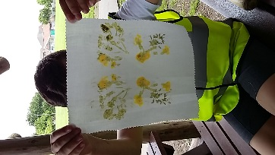 |  |  | Vocabulary
Flower
Bee
Pollination
Nectar
Pollen
Anther
Filament
Stigma
Style
Ovary
Carpel
Stamen
Habitat
Adaptation

Plenary | Recap the importance of flowers and bees to the world. What could we do to better their chances of survival. | Evaluation

