Outdoor Education Plan
Lesson Focus – Geography Signs Post
Year Group - |  | Term - | Date –
 | Outline | Curriculum Links/  Learning Objectives | Health and Safety considerations | Equipment
Session Procedures | Before - Check for rubbish, glass, hazards. Check weather forecast  During – Wear Hi-Viz jacket. Road safety to get to the park  After – clear everything away and return any natural objects to their original place  Clean hands. | I can locate North, South, East and West  I can research how far away a country is from the UK | Wash hands after touching outside objects  Remind the children about how sharp some sticks can be and to be careful of brambles and stinging nettles.  Remind children to be careful not to let the sticks fly out of their hands and go in someone else’s eye.  Gloves must be worn for both litter picking and gardening | Wooden planks  Paint  Compass  Paintbrushes  Outdoor varnish
Introduction and Activity Opportunities | Main Activity  - Each team is given a country to research, they need to find out which direction it is in from Bristol and how far away it is.  - They can decide on a picture which is a highlight of the country they have researched.  - The team draws out the countries name and distance in bubble writing  - They paint it carefully  - The teacher varnishes the paint to make it weather proof if it is going outside.  - Another option is to make signs that point to the imaginary locations of the children’s favourite books  - The activity could be done more temporarily by using cardboard.  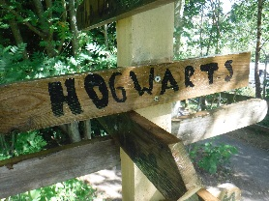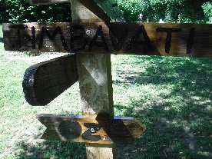 |  |  | Vocabulary
Direction
Distance
Location
Geography

Plenary | Where on the sign would like to go? | Evaluation

