Outdoor Education Plan
Lesson Focus – Knowledge of the importance of Bees / Use of junior bowsaw
Year Group - Whole school |  | Term - | Date – Week
 | Outline | Curriculum Links/  Learning Objectives | Health and Safety considerations | Equipment
Session Procedures | Before - Check for rubbish, glass, hazards. Check weather forecast  During – Watch that children do not try to cut corners around the school grounds  - Children must wear gloves for litter picking and planting  After – clear everything away and return any natural objects to their original place  Clean hands. | I can use tools to make a bee hotel.  I understand that bees are essential for the survival of our food produce.  Science  - Pollination  - Hibernation  Art/DT  - 3D design  - Sculpture  - Using tools  PSHE  - Looking after nature  Numeracy  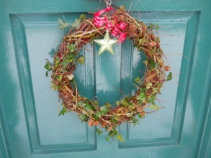  - Measure  - Shape - hexagons | Wash hands after touching outside objects  Remind the children about how sharp some sticks can be and to be careful of brambles and stinging nettles.  Remind children to be careful not to let the sticks fly out of their hands and go in someone else’s eye.  Gloves must be worn for both saw and drill  1:1 assistance using saw | Tins  Bamboo  Sticks  Willow
Introduction and Activity Opportunities | Problem Solving Activity – Waggle Dance Game. Shows how teamwork is the most important part of a bee colony life. http://www.devonwildlifetrust.org/i/Brilliant_Bees_Curriculum_Resource.pdf  Main Activity – Bee Hotel  - Recap – what are the rules of the Forest?  - Discuss why we need bees and why they may need shelter over the winter (link hedgehog and shelter building last week). Discuss pollination and importance to our survival  - We are going to look at the tools that we will be using – mini bow saw. SAFETY.  - The bamboo needs to be measured accurately to fit into the tin can.  - Attach bamboo to the table using the clamp  - Mark where the cut is going to be made  - Hold the bamboo using the gloved hand and your partner holding the bamboo above the clamp  - Saw slowly and steadily making sure that you let the saw do the work – do not push down.  - When finished put the bamboo into the tin can ready for the bees.  Christmas Wreath (children do this independently so that adults can work with tools)  - Recap using the willow in the dream catchers.  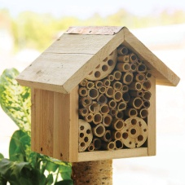  - Slowly bend the willow all the way along to create a ring.  - Tie the willow into itself by winding it around itself  - Decorate with items from the school grounds – autumn leaves/evergreen  Branches (Year One – collect leaves before starting)  KS1 in class – Activity One/Two: Bee activity in class |  |  | Vocabulary
Bee
Pollination
Ecology
Saw
Clamp

Plenary | Plenary :  Recap what the bees mean to us. How can we help them in the future. | Evaluation

